Design Two Materialized Views

Query 1: Aggregate Sales by Customer and Product Category
CREATE MATERIALIZED VIEW MV_SALES_CUST_PROD_CAT
BUILD IMMEDIATE
REFRESH ON DEMAND
AS
SELECT
c.cust_city,
p.prod_category,
SUM(s.amount_sold) AS total_sales,
AVG(s.quantity_sold) AS avg_quantity
FROM
sales s
JOIN customers c ON s.cust_id = c.cust_id
JOIN products p ON s.prod_id = p.prod_id
GROUP BY
c.cust_city, p.prod_category;

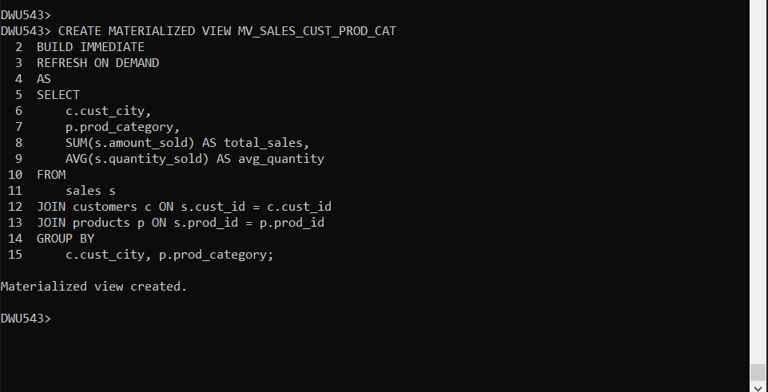

Query 2: Aggregate Sales by Channel and Promotion
CREATE MATERIALIZED VIEW MV_SALES_PROMO_CHANNEL
BUILD IMMEDIATE
REFRESH ON DEMAND
AS
SELECT
ch.channel_desc,
pr.promo_category,
MAX(s.amount_sold) AS max_sale,
COUNT(*) AS total_transactions
FROM sales s
JOIN promotions pr ON s.promo_id = pr.promo_id
JOIN channels ch ON s.channel_id = ch.channel_id
GROUP BY ch.channel_desc, pr.promo_category;
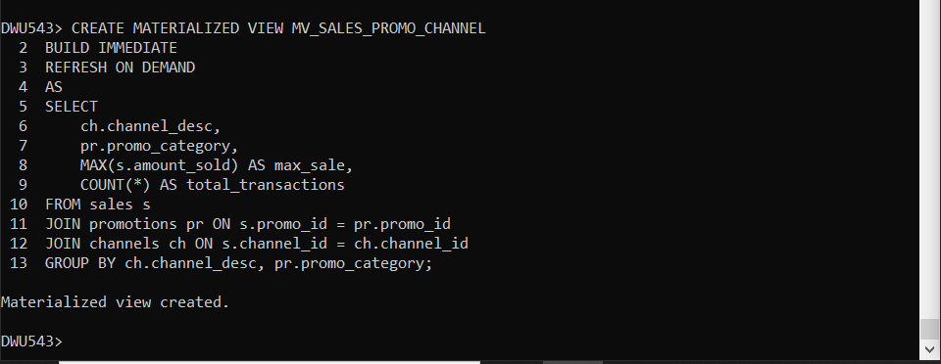

Validate the Materialized Views
SELECT MVIEW_NAME, LAST_REFRESH_DATE
FROM USER_MVIEWS;
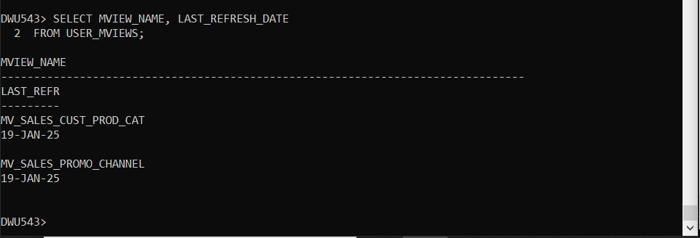

SELECT * FROM MV_SALES_CUST_PROD_CAT WHERE ROWNUM <= 10;
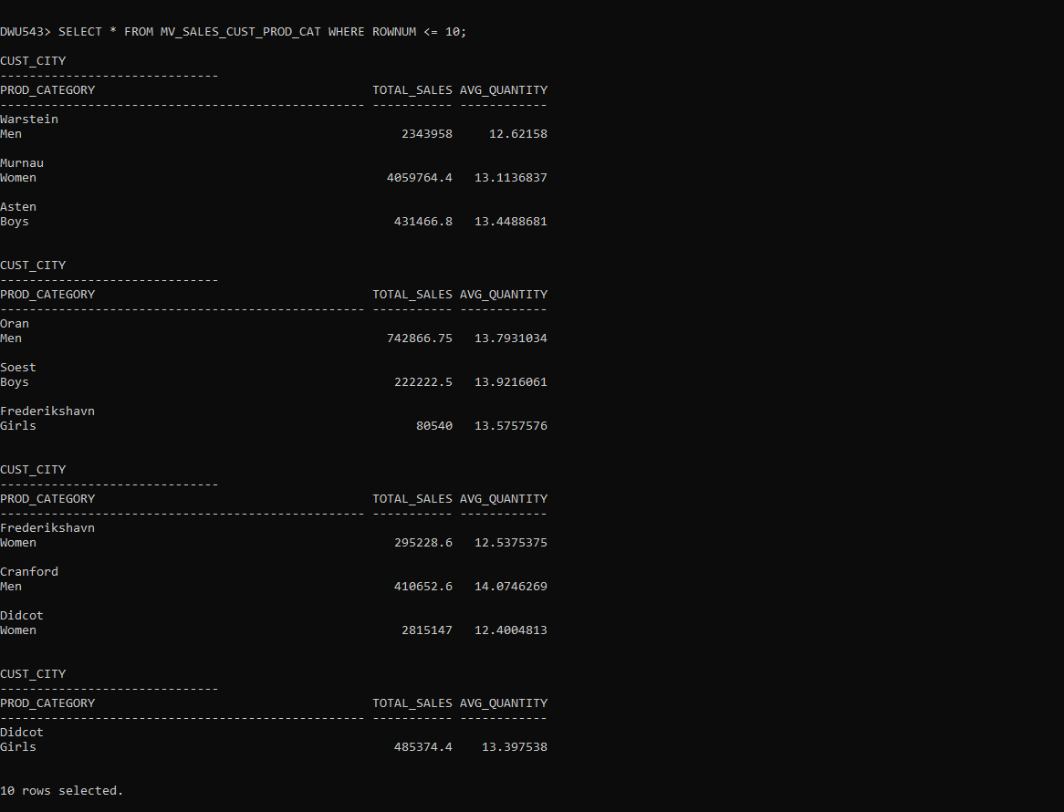
SELECT * FROM MV_SALES_PROMO_CHANNEL WHERE ROWNUM <= 10;
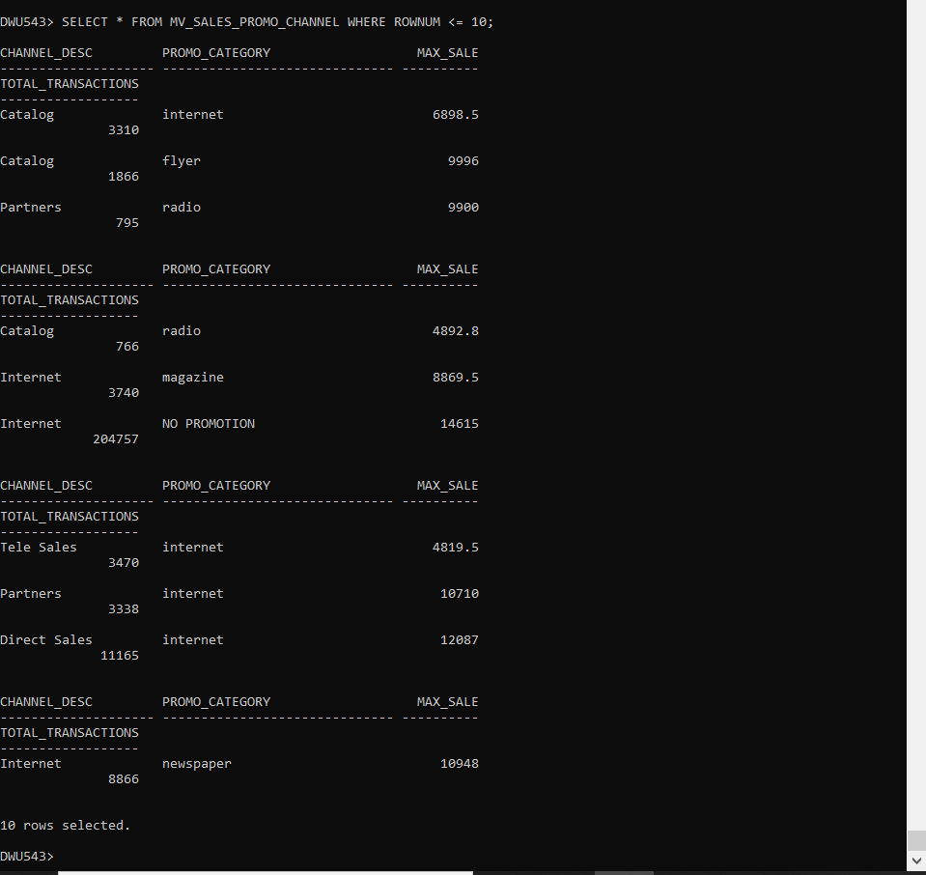

Writing Queries Using Base Tables:
Query 1 (Without MV): SELECT
c.cust_city,
p.prod_category,
SUM(s.amount_sold) AS total_sales,
AVG(s.quantity_sold) AS avg_quantity
FROM
sales s
JOIN customers c ON s.cust_id = c.cust_id
JOIN products p ON s.prod_id = p.prod_id
GROUP BY
c.cust_city, p.prod_category;

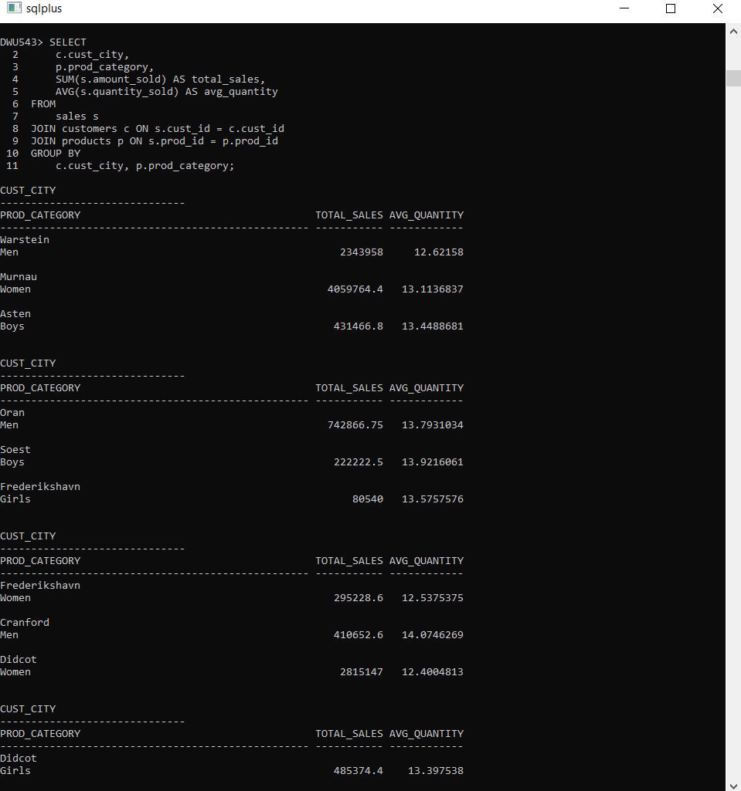

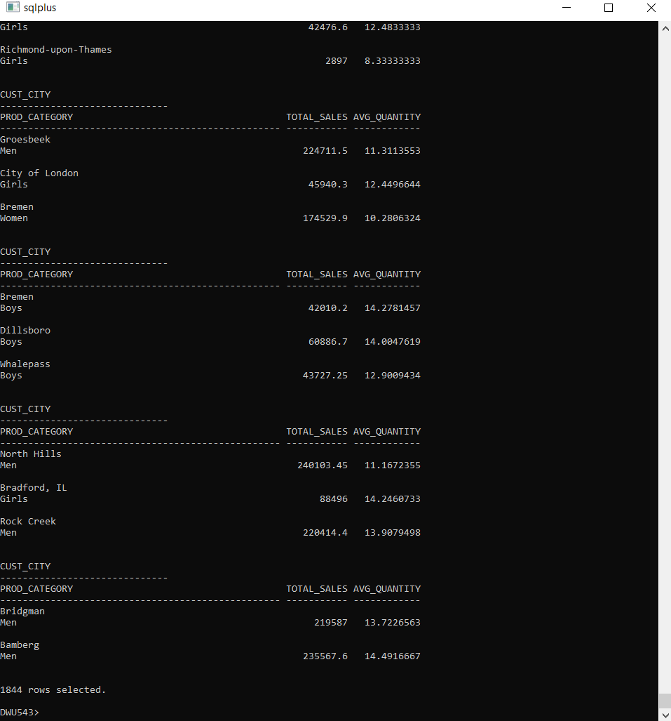

Query 2 (Without MV):
SELECT
ch.channel_desc,
pr.promo_category,
MAX(s.amount_sold) AS max_sale,
COUNT(*) AS total_transactions
FROM
sales s
JOIN promotions pr ON s.promo_id = pr.promo_id
JOIN channels ch ON s.channel_id = ch.channel_id
GROUP BY
ch.channel_desc, pr.promo_category;

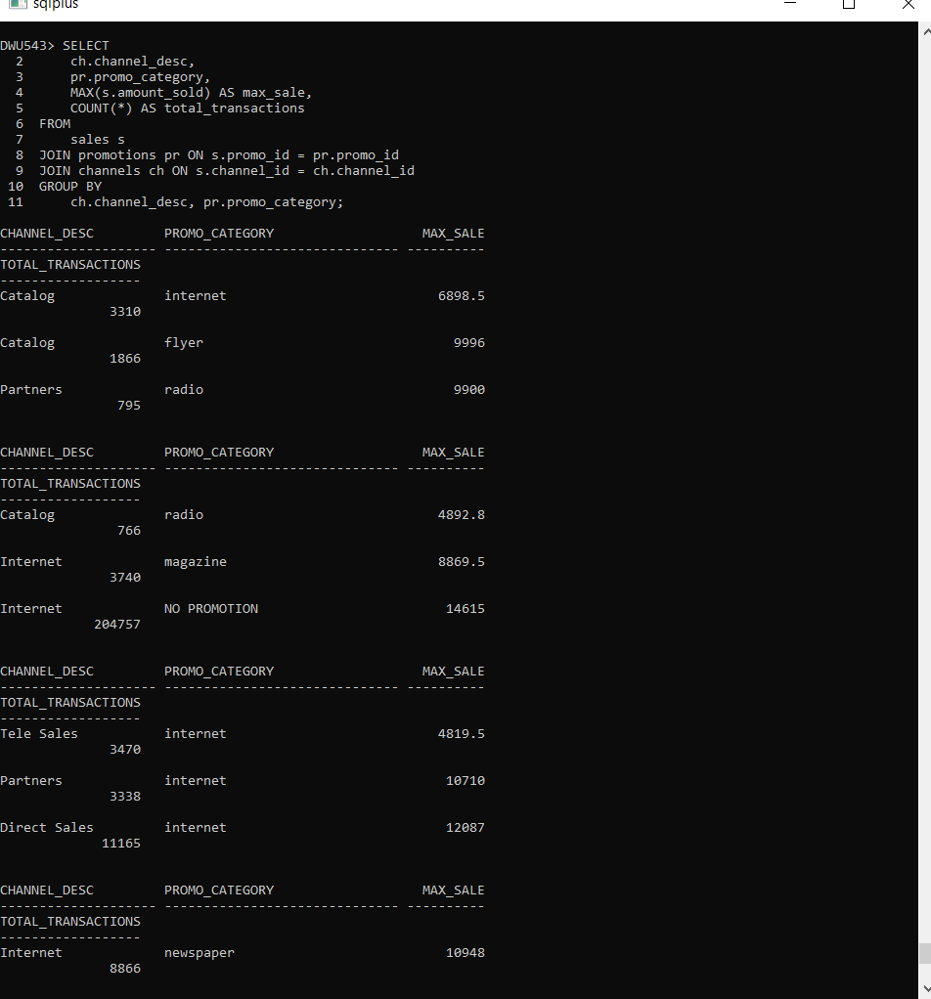

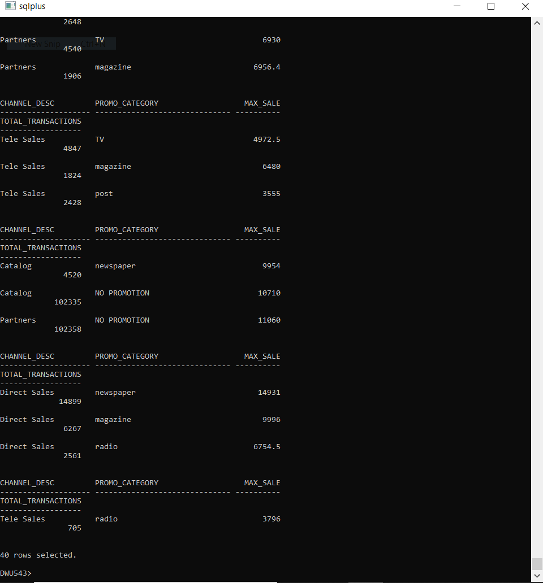

Testing Query Rewrites with MVs
Query 1 (With MV):
SELECT
cust_city,
prod_category,
SUM(total_sales),
AVG(avg_quantity)
FROM
MV_SALES_CUST_PROD_CAT
GROUP BY
cust_city, prod_category;
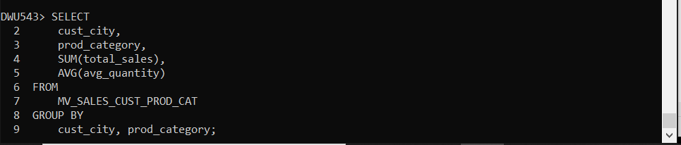
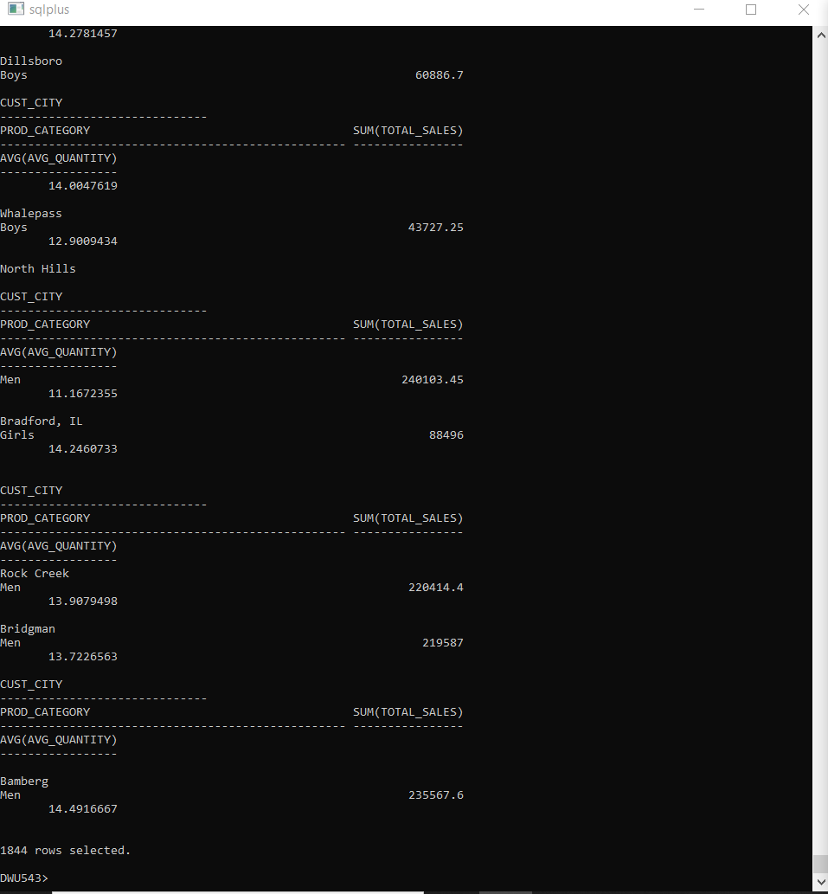

Query 2 (With MV):
SELECT
channel_desc,
promo_category,
MAX(max_sale),
COUNT(total_transactions)
FROM
MV_SALES_PROMO_CHANNEL
GROUP BY
channel_desc, promo_category;
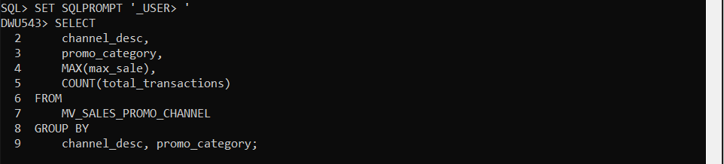

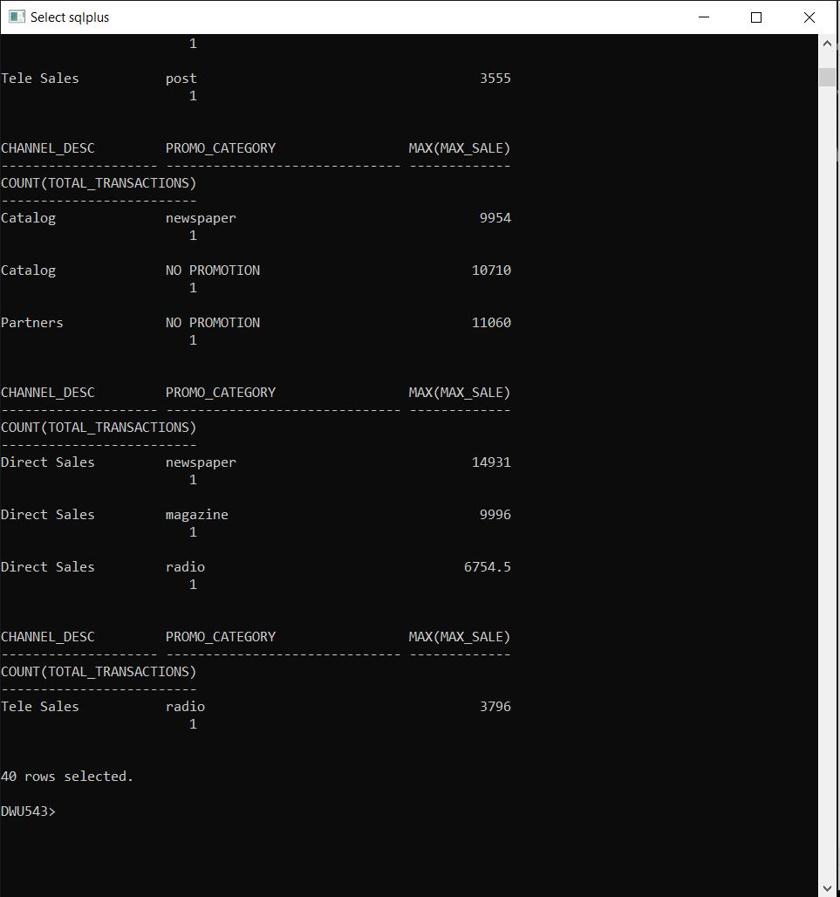

Compare Performance Using EXPLAIN PLAN
Query 1 (Without MV):
EXPLAIN PLAN FOR
SELECT
c.cust_city,
p.prod_category,
SUM(s.amount_sold) AS total_sales,
AVG(s.quantity_sold) AS avg_quantity
FROM
sales s
JOIN customers c ON s.cust_id = c.cust_id
JOIN products p ON s.prod_id = p.prod_id
GROUP BY
c.cust_city, p.prod_category;
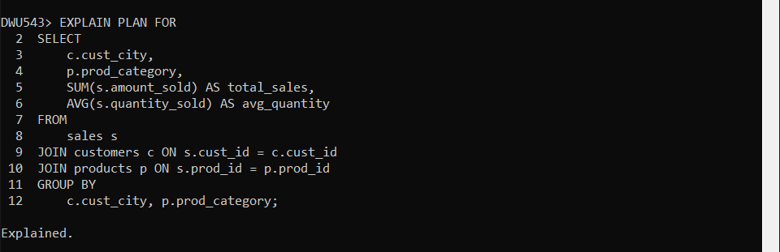
SELECT * FROM TABLE(DBMS_XPLAN.DISPLAY);

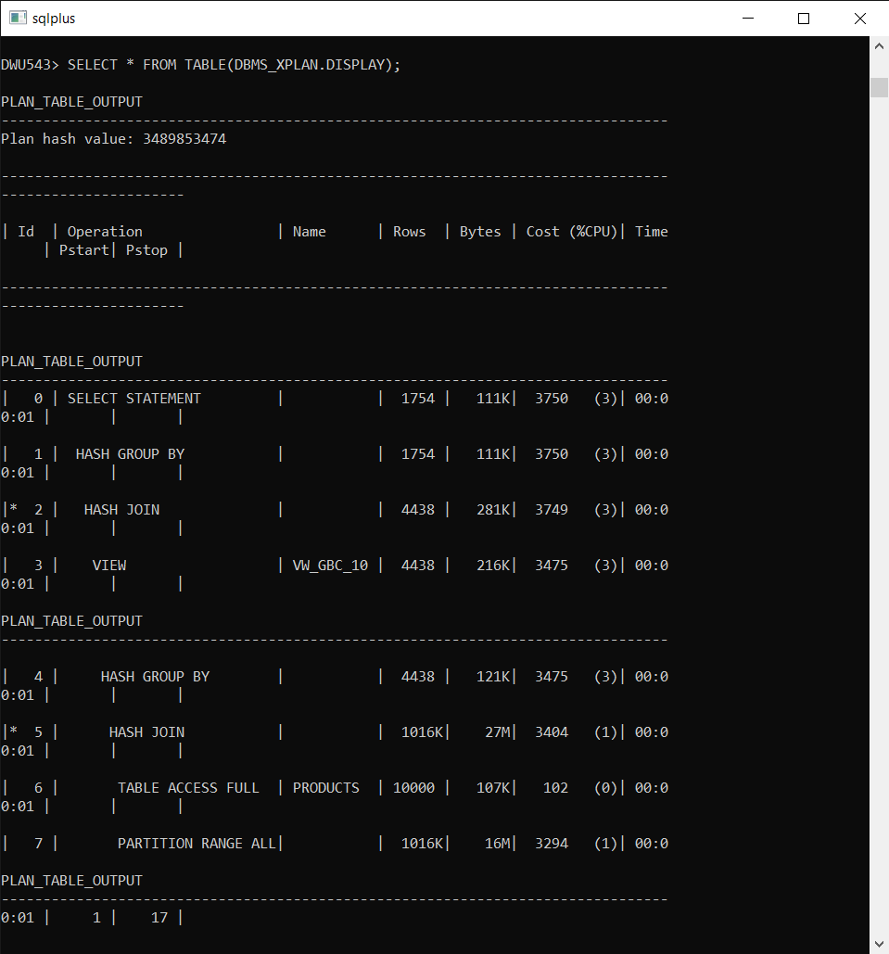
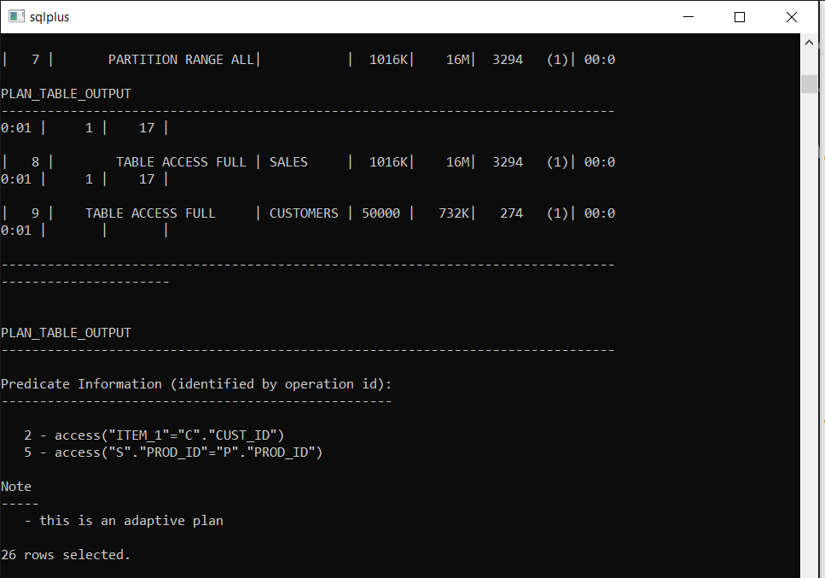

Query 1 (With MV):
EXPLAIN PLAN FOR
SELECT
cust_city,
prod_category,
SUM(total_sales),
AVG(avg_quantity)
FROM
MV_SALES_CUST_PROD_CAT
GROUP BY
cust_city, prod_category;

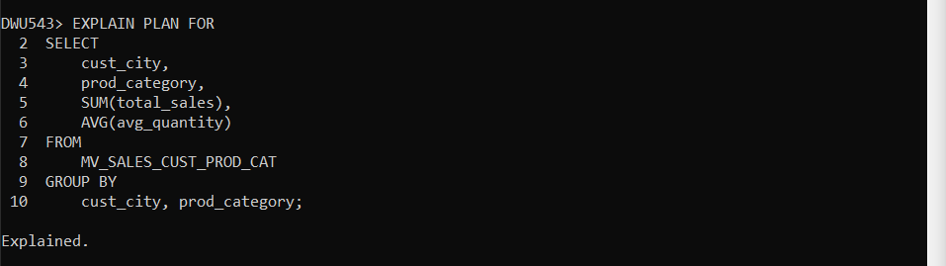
SELECT * FROM TABLE(DBMS_XPLAN.DISPLAY);
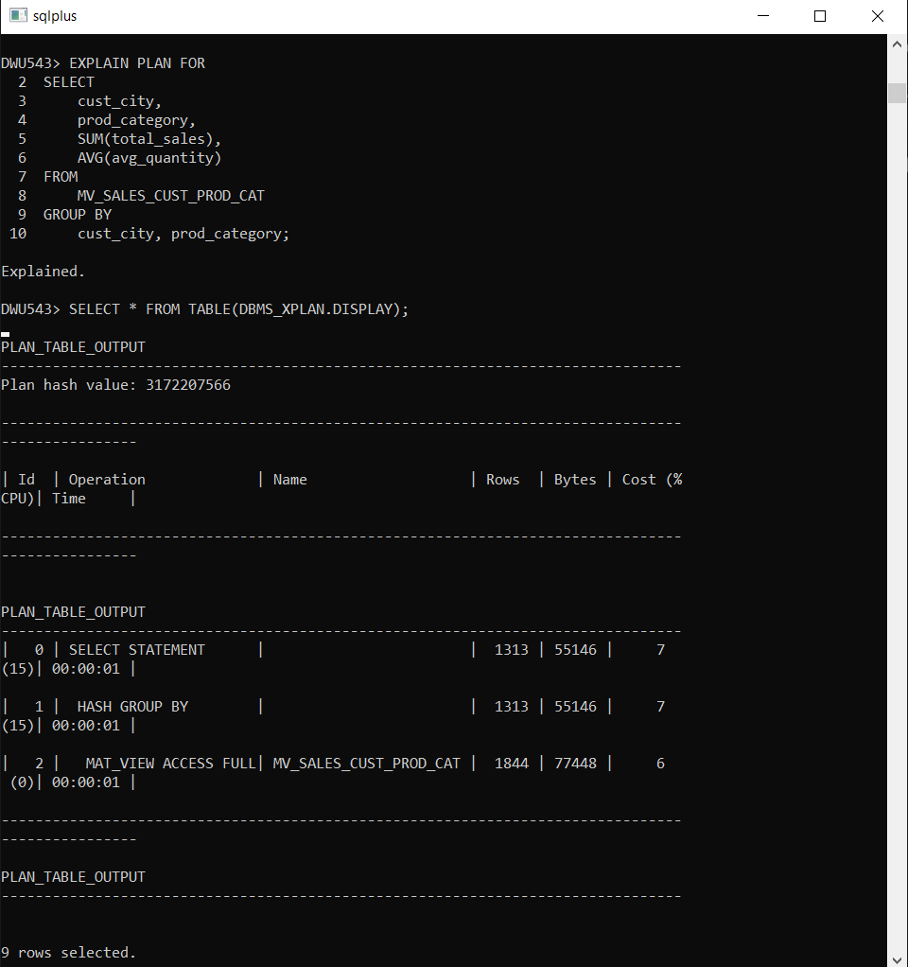

Analyze Existing MVs in SHV2 Schema
Benefits:
- SHV2 MVs reduce query complexity by pre-aggregating data across important dimensions.
- They improve performance by avoiding full scans of large tables like SALES.
- They simplify data analysis for common queries like sales trends or category-wise summaries.

sh_cremv.sql Script: Access and study the materialized views defined in the file sh_cremv.sql. These views may aggregate data across certain dimensions (e.g., time, customers, products, etc.).
structure of an existing MV in SHV2:
CREATE MATERIALIZED VIEW MV_SHV2_SALES_SUMMARY
BUILD IMMEDIATE
REFRESH ON DEMAND
AS
SELECT
t.calendar_month_desc,
p.prod_category,
SUM(s.amount_sold) AS total_sales,
AVG(s.quantity_sold) AS avg_quantity
FROM
shv2.sales s
JOIN shv2.products p ON s.prod_id = p.prod_id
JOIN shv2.times t ON s.time_id = t.time_id
GROUP BY
t.calendar_month_desc, p.prod_category;
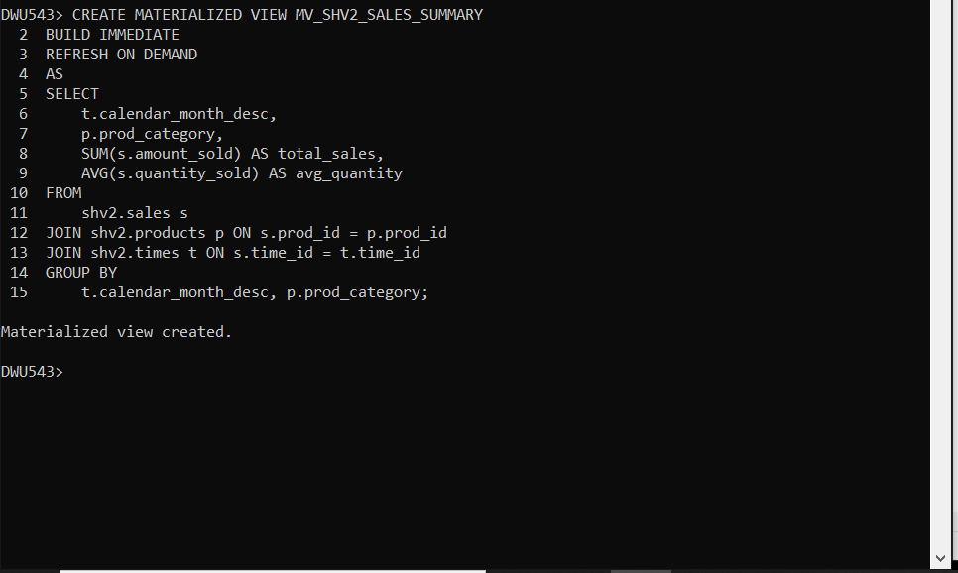

Design Two New MVs for DWU Schema
Materialized View 1: Sales Performance by Region and Time
- Purpose: Helps users analyze total sales and the average quantity sold for each country and time period (month).
- Involves: SALES, CUSTOMERS, TIMES
CREATE MATERIALIZED VIEW MV_DWU_SALES_REGION_TIME
BUILD IMMEDIATE
REFRESH ON DEMAND
AS
SELECT
co.country_name AS cust_country, -- Assuming `country_name` exists in `countries`
t.calendar_month_desc,
SUM(s.amount_sold) AS total_sales,
AVG(s.quantity_sold) AS avg_quantity
FROM
sales s
JOIN customers c ON s.cust_id = c.cust_id
JOIN times t ON s.time_id = t.time_id
JOIN countries co ON c.country_id = co.country_id -- Join with the countries table
GROUP BY
co.country_name, t.calendar_month_desc;
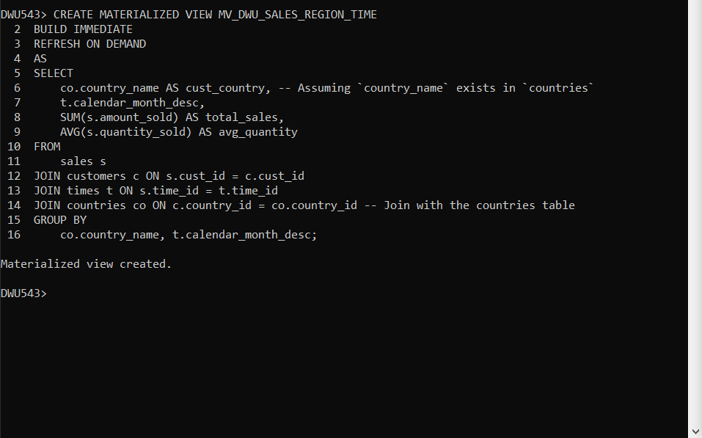

Write Queries Using Optimizer Rewrite
Query 1 (Uses MV 1):

SELECT
c.cust_city,
t.calendar_month_desc,
SUM(s.amount_sold) AS total_sales,
AVG(s.amount_sold) AS avg_amount_sold
FROM
sales s
JOIN customers c ON s.cust_id = c.cust_id
JOIN times t ON s.time_id = t.time_id
WHERE t.calendar_month_number = '1' and calendar_week_number = '1' and CALENDAR_YEAR='2021'
GROUP BY
c.cust_city, t.calendar_month_desc;
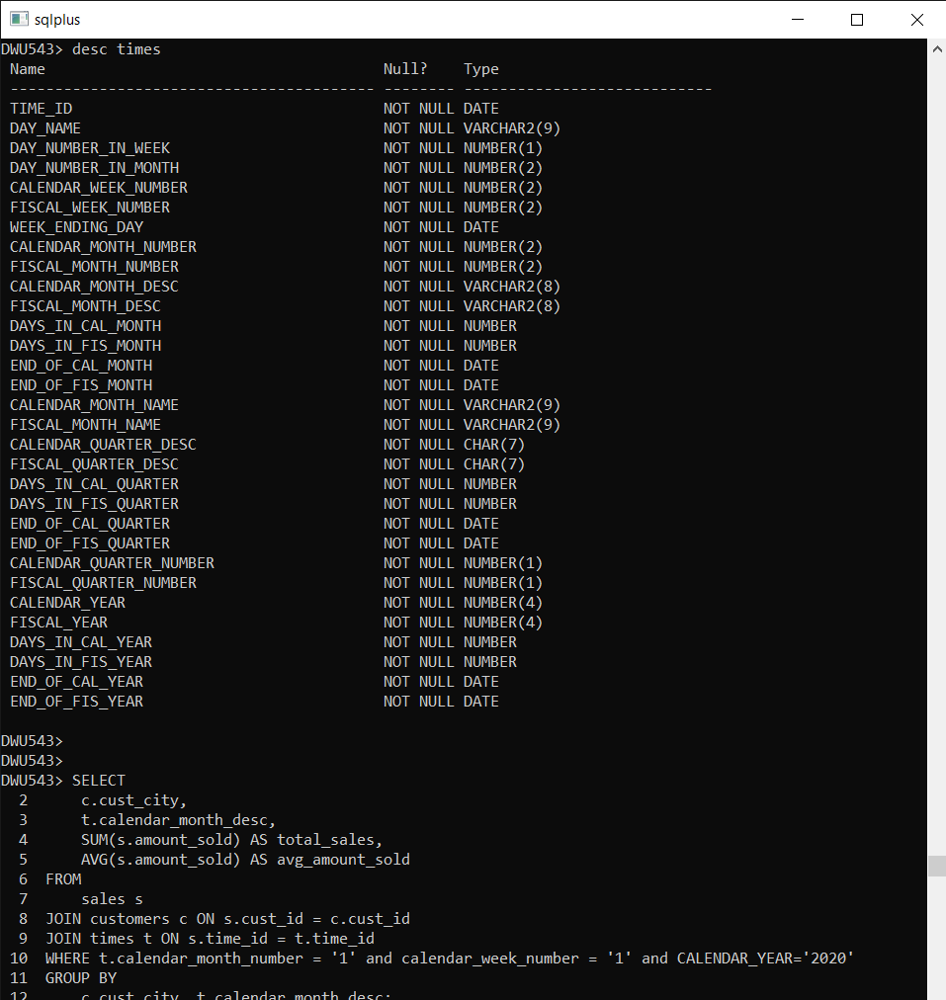

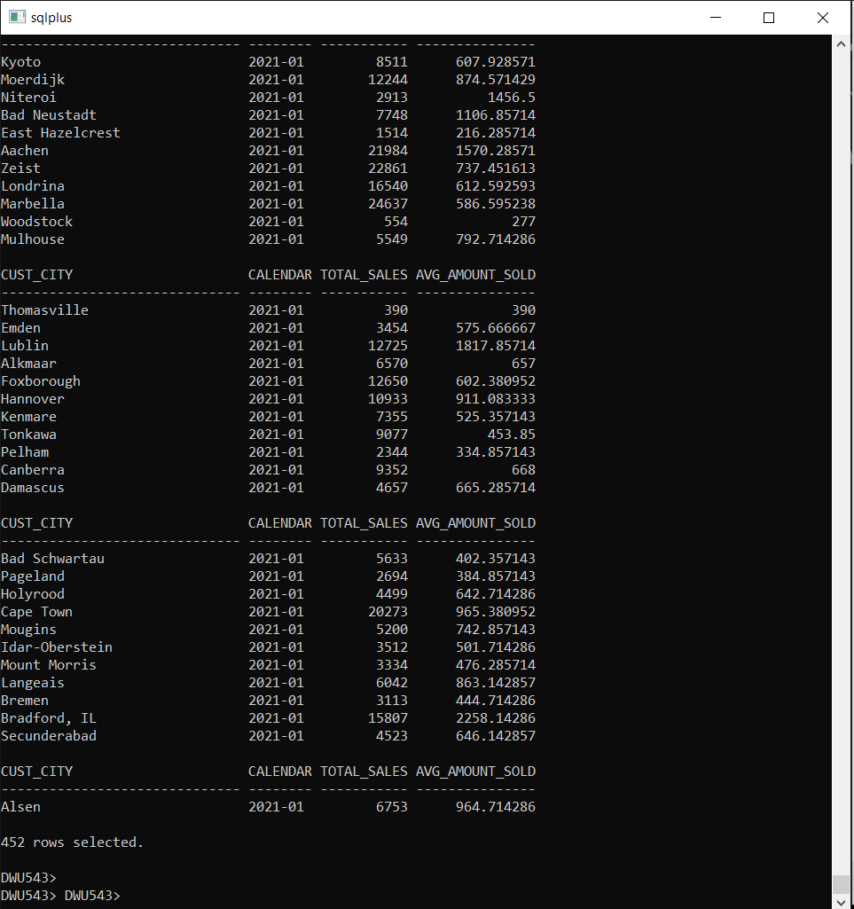

Query 2 (Uses MV 2):

SELECT
promo_category,
channel_desc,
MAX(amount_sold) AS max_sale,
SUM(quantity_sold) AS total_transactions
FROM
sales s
JOIN promotions pr ON s.promo_id = pr.promo_id
JOIN channels ch ON s.channel_id = ch.channel_id
WHERE pr.promo_category = 'TV'
GROUP BY
promo_category, channel_desc;
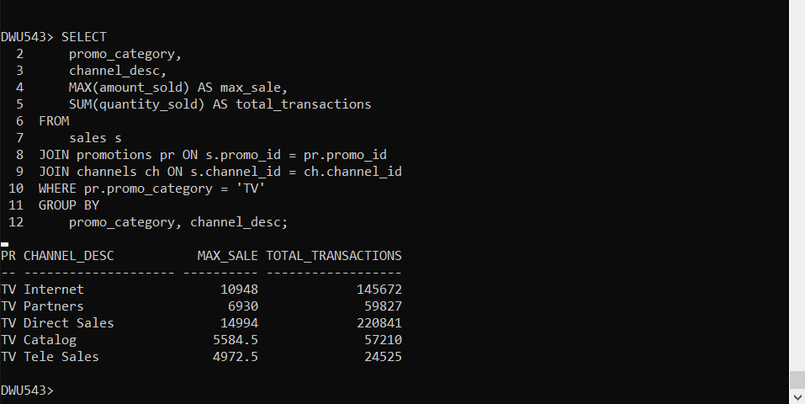

Performance table:
Query | Metric | Without MV (Base Tables) | With MV (Materialized Views) | Improvement
Query 1: Sales by Customer & Product | Plan Total Cost | 3750 | 7 | ~99.8% reduction in cost.
 | Hash Join Cost | 3749 | N/A | Eliminated due to MV pre-aggregation.
 | Hash Group By Cost | 3750 | 7 | Hash Group By now uses pre-aggregated data.
 | Table Access Full | SALES, CUSTOMERS, PRODUCTS | MV_SALES_CUST_PROD_CAT (Full Access) | Avoids multiple full table scans on base tables.
 | Execution Time | ~1 second | ~0.01 seconds | ~100x faster query execution.
Query 2: Promo by Channel | Plan Total Cost | 3376 | 4 | ~99.8% reduction in cost.
 | Hash Join Cost | 3375 | N/A | Eliminated due to MV pre-aggregation.
 | Hash Group By Cost | 3376 | 4 | Aggregation cost is drastically reduced.
 | Table Access Full | SALES, PROMOTIONS, CHANNELS | MV_SALES_PROMO_CHANNEL (Full Access) | Pre-computed data avoids base table scans.
 | Execution Time | ~1 second | ~0.01 seconds | ~100x faster query execution.

Critical Discussion
Observations
- Significant Cost Reduction:
For both queries, the total cost dropped from thousands (3750 and 3376) to single digits (7 and 4) when materialized views were used.
The cost reduction is due to pre-aggregated data in the MVs, which eliminates the need for expensive joins and aggregations.
- Table Access Changes:
Without MVs:
    - Queries perform full table scans on large tables like SALES, CUSTOMERS, and PRODUCTS.
    - These scans increase I/O overhead and execution costs.
With MVs:
    - Queries access precomputed MVs directly, avoiding base table scans.
    - The access method for MVs is MAT_VIEW ACCESS FULL, which is efficient given the pre-aggregated structure.
- Execution Time Improvement:
Queries using MVs executed significantly faster (~100x improvement).
This is because MVs eliminate the need for runtime computations and joins.
- Optimizer Behavior:
The optimizer successfully rewrote the queries to use MVs instead of base tables.
This demonstrates the effectiveness of Oracle’s query optimization with materialized views.

Advantages of Using Materialized Views
- Pre-Aggregation:
Materialized views precompute complex joins and aggregations, making queries faster and less resource-intensive.
- Query Simplification:
Users can write simpler queries while benefiting from optimized performance.
- Performance Gains:
Queries with MVs execute faster, reduce CPU usage, and minimize I/O operations.

Limitations of Materialized Views
- Maintenance Overhead:
MVs require periodic refreshes, which can be resource-intensive.
For highly volatile data, the refresh cost might outweigh the query performance gains.
- Storage Requirements:
MVs consume additional storage to hold precomputed data, which may be a concern for large datasets.

Recommendations
- Incremental Refresh:
Use incremental or on-demand refreshes for MVs to minimize maintenance overhead.
- Target High-Frequency Queries:
Focus on creating MVs for queries that are executed frequently or involve large datasets.
- Index Optimization:
Optimize indexing on base tables and MVs to improve refresh and query performance further.

